WINDOWS FUNDAMENTALS 3

SOMILA. SA

231901052

EX.NO:01 Date: 12-02-2025

AIM: In part 3 of the Windows Fundamentals module, learn about the built-in Microsoft tools that help keep the device secure, such as Windows Updates, Windows Security, BitLocker, and more. PROCEDURE:

• Task 1: Introduction

• Task 2: Windows Updates

• Task 3: Windows Security

• Task 4: Virus & threat protection

• Task 5: Firewall & network protection

• Task 6: App & browser control

• Task 7: Device security

• Task 8: BitLocker

• Task 9: Volume Shadow Copy Service

• Task 10: Conclusion TASKS:

Task 1:

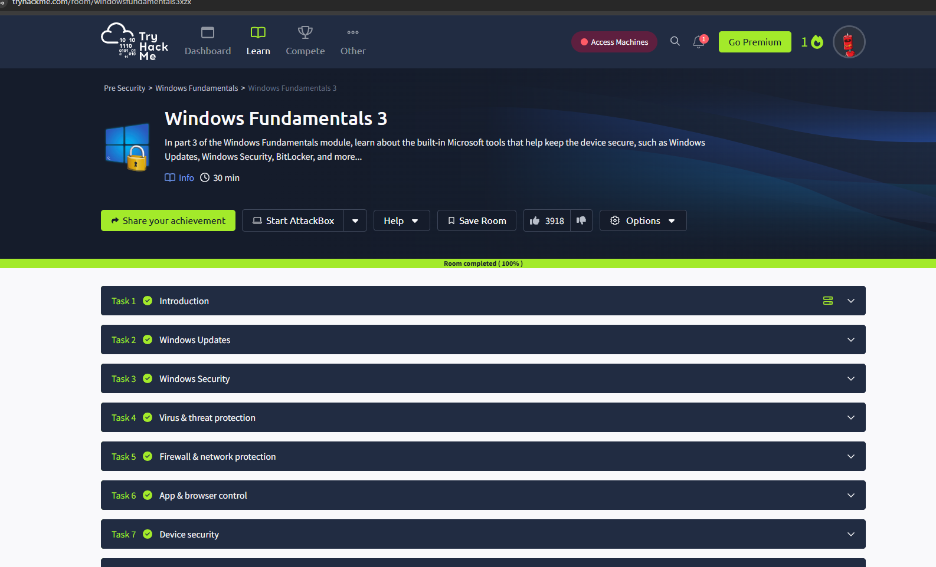

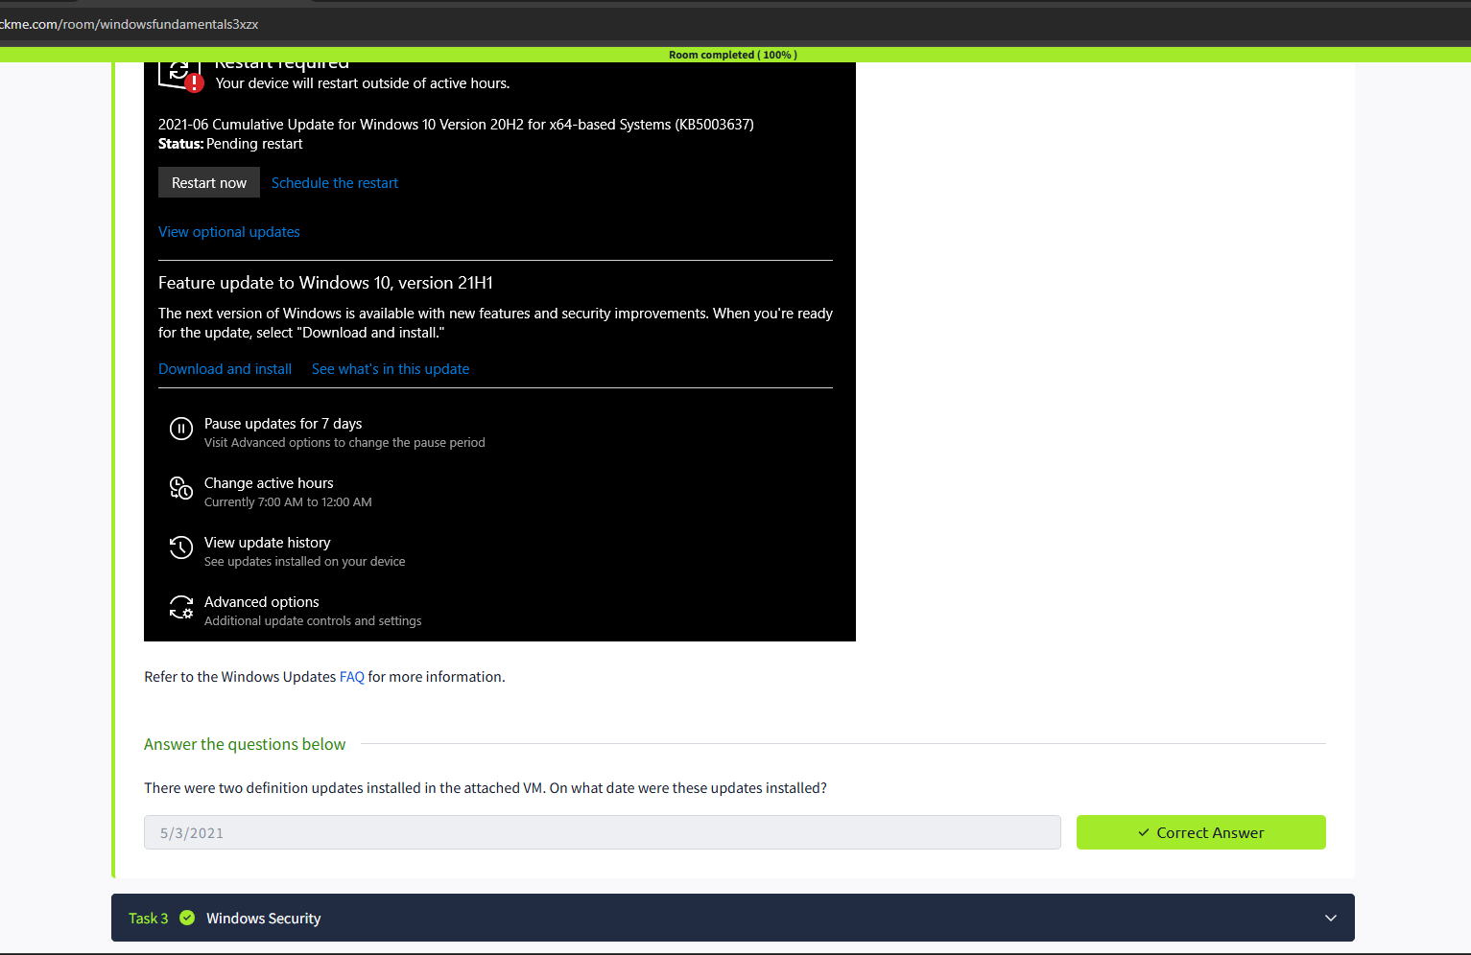

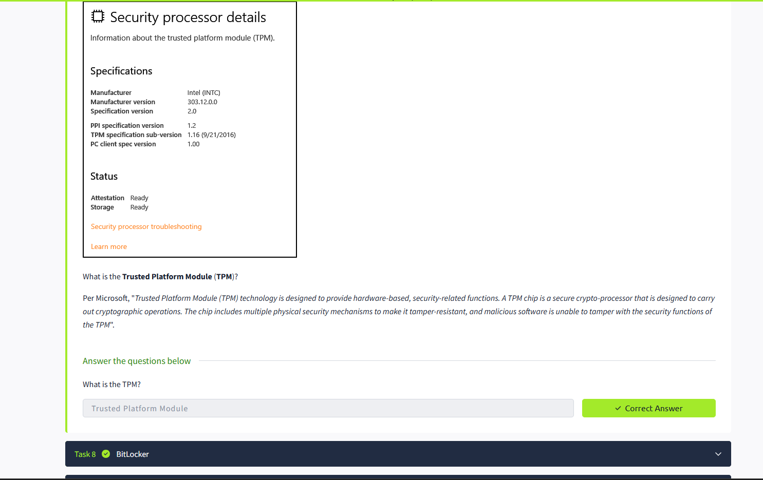

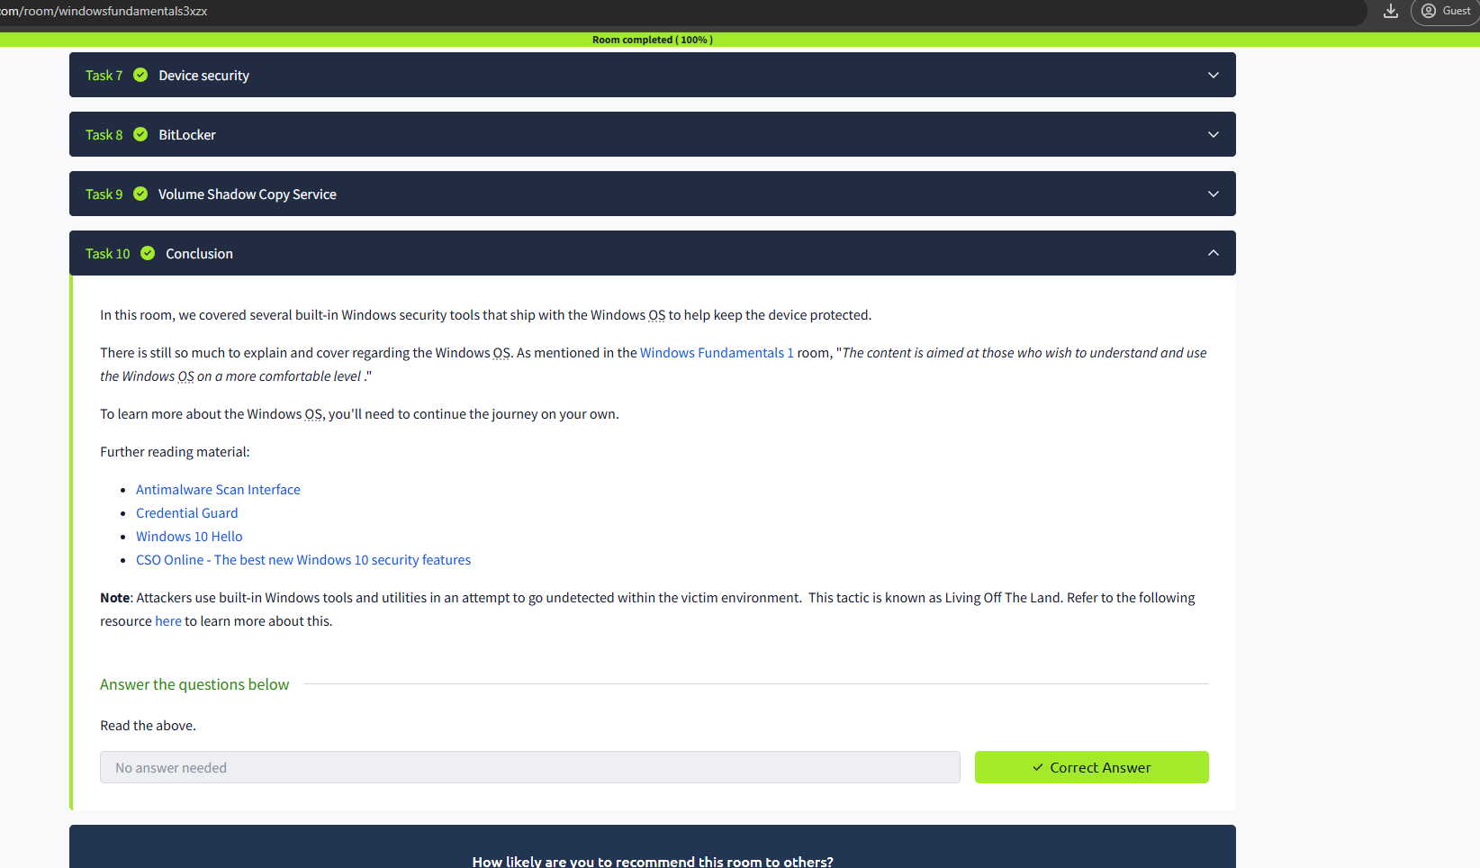

RESULT: Thus the windows fundamentals 3 successfully completed in tryhackme platform.